Machine Learning Pipeline
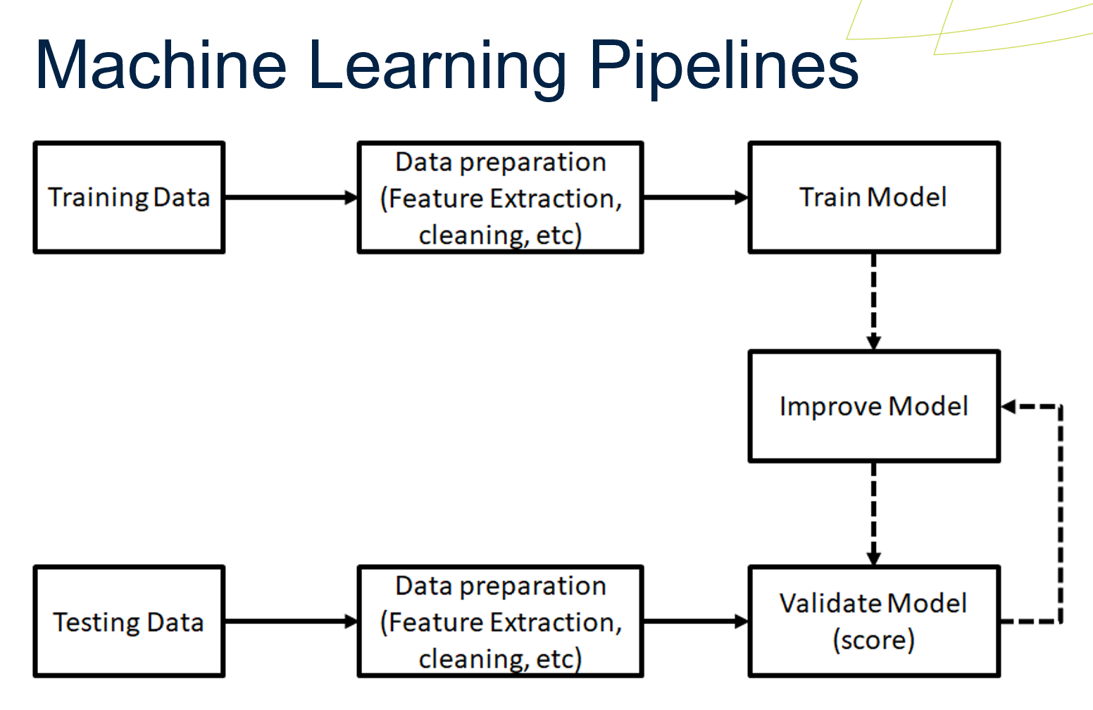
Figure 1. Machine Learning Pipeline Development
Figure 1 shows, the processes of how machine learning during developing , which steps are as follow :
- Training Data : load acquired training datasets by using Pandas libraries , split the dataset into training and test sample by using Skicit-learn libraries.
- Data Preparation : Define features has been selected and handling missing value.
- Train Model : Build decision trees model by using DecisionTreeClassifier from Skicit-learn libraries , set up decision trees conditions model , train the model by using trained dataset by using Numpy,Pandas and Skicit-Learn libraries .
- Testing Data : Prepare test cases and test datasets either captured new traffic dataset or download from secondary dataset.
- Data Preparation : define features testing datasets , normalisation dataset and define features.
- Validate Model : validated and evaluate test cases result report by using
trained decision tree models , Skicit-learn metrics and seaborn libraries.
- Improve Model : Finally, if the model performances score did not achieved as expected, improve the decision tree model until achieved target score. Once it has archived the target score, implement and deploy the machine model.

Data Collection
Following the discussion of dataset would be used based on Literature review, IoTID20 dataset would be acquired from Kaggle .com and testing data would be considered to captured traffic either by using CICFlowMeter and convert it from Pcap into CSV , capture by using tcp dump and convert it from pcap into CSV or acquire new CIC dataset from credible source.

Feature Selection
There are 7 from 85 feature has been taken in order to be able achieved high performances score , which are Dst_Port, Source_Port, Packet Size Average , Flow Duration, Protocol, SYN flag and ACK flag.

Scan
Firstly, when attacker trying to exploit network vulnerability, vulnerability scans such as perfom nmap would be the first step to identify which services could be use as access to perfom attacks.
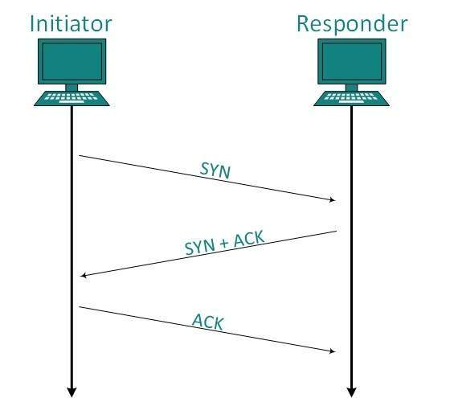
Figure 2. Network Discovery Scan Flow
Figure 2 show, flow on how attacker performing network discovery scan by using nmap command, it showing SYN and ACK packet are been sent in order to get which port number could be accessed to perform further attacks. Therefore, destination port,Flow duration,SYN and ACK flag feature has been chosen in order to detect scan intrusion.

Mirai / Botnet
Thirdly, packet size , ACK and SYN flag feature has been consider as well caused infected devices could automatically run attacks such as DoS at specific time or event. Also, flow duration feature has been considered as well when botnet launching DoS attack .

DoS
Fourthly, when attacker performing DoS , flooding SYN packet to target in order to disturbing their availability service caused each SYN packet has received , should be replied with ACK packet as shown in figure 2 . Therefore, Flow duration,packet size average ,SYN and ACK flag feature has been chosen , including Dst_Port , Source_Port and protocol to able quarantine which services and ports number has sent flood packets into the system network.

MITM
Secondly, following explanation on Scan, DoS and Botnet , then we have considered each features on those intrusion has related to Man-in-the-middle attacks caused compromised credential and breached of authentication .

Finding and Result

Decision Tree 1
Based on selected features , the decision tree model 1 has been created by using Sklearn tree libraries. Also , performance result has been generated such as confusion matrix and classification report by using sklean metric libraries , as shown in figure 3 and 4 .

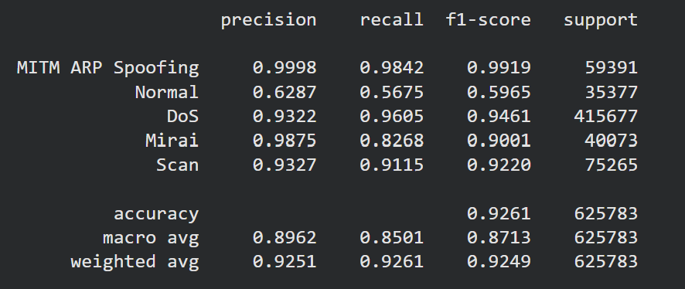
Figure 3. Classifcation Report Decision Tree 1
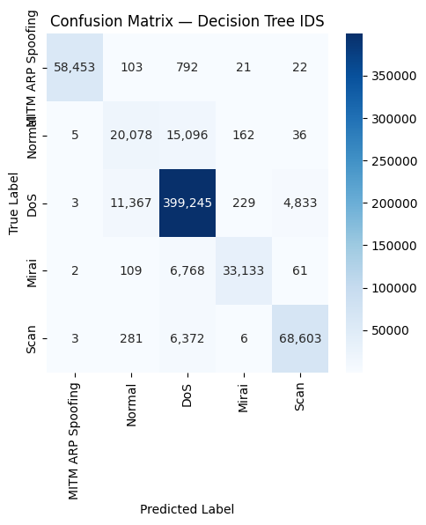
Figure 4. Confusion Matrix Decision Tree 1

Decision Tree 2
Also , the decision tree model 2 has been created and performance result has been generated for confusion matrix and classification report, as shown in figure 5 and 6 .
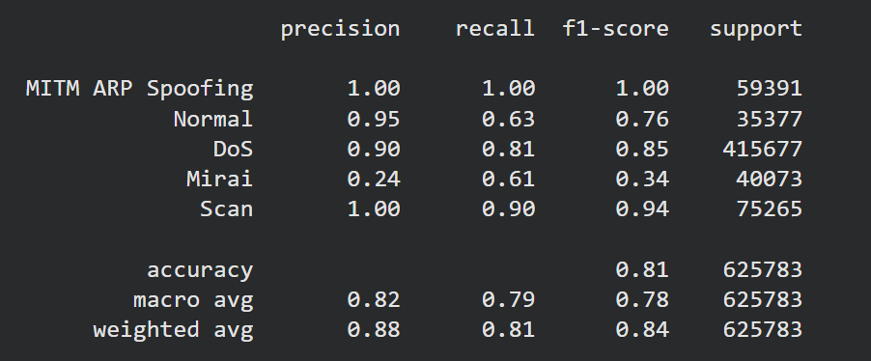
Figure 5. Classification Report Decision Tree 2
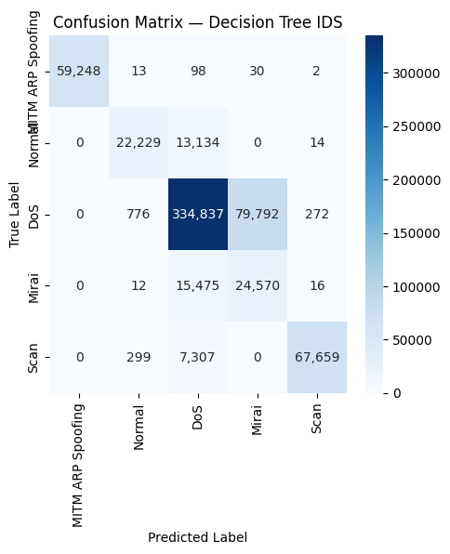
Figure 6. Confusion Matrix Decision Tree 2

Decision Tree 3
Also , the decision tree model 2 has been created and performance result has been generated for confusion matrix and classification report, as shown in figure 7 and 8 .
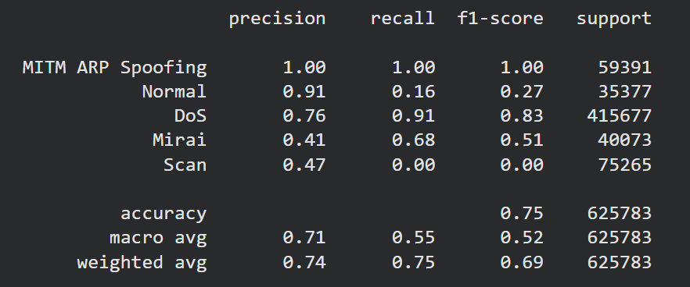
Figure 7. Classification Report Decision Tree 3
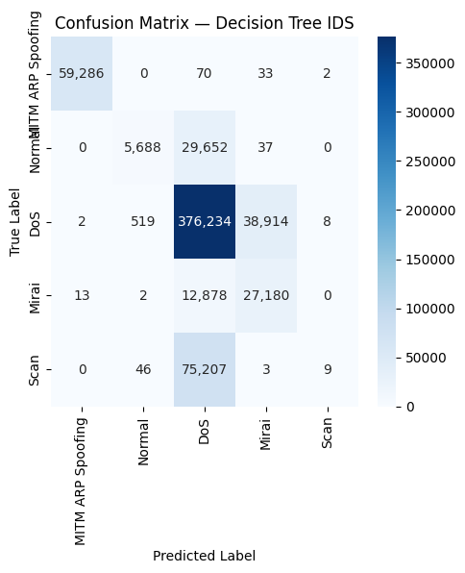
Figure 8. Confusion Matrix Decision Tree 3

Random Forest
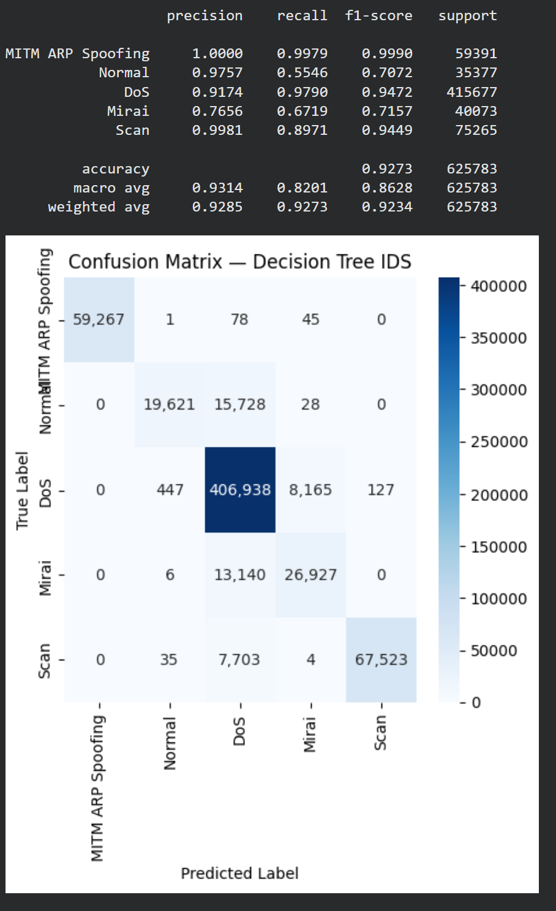
Figure 9. Classification Report and Confusion Matrix Random Forest

Based on result analysis on random forest model as show in figure 9 , from 3 decision tree result has been trained, the result has been combined and decided based on majority , which it showing the model has improved accuracy, precision number for DoS and Scan intrusion detection. However, the model has been analysed by network traffics has been captured for each attack such as SYN DoS,ICMP DoS, Scan and Bruteforce attack , explains it needed to be optimized and features are need to be reconsider to improve precision of each intrusion.

